**Project Description:**

**TTTAPP** is a simple Android application created by Gatal and Hao of Team UNRL with the idea of assisting users who often struggle to track their tap-to-pay transactions using multiple NFC wallet apps. The application’s main goal is to provide a clear and unified history of a user’s NFC wallet activity, helping them confirm if payments were successful and avoid confusion caused by checking different apps. TTTAPP is designed to help users stay informed and in control of their contactless payments. The intended users for the application are Android users especially college students and young adults who regularly use mobile wallets such as GCash, PayMaya, or Google Pay for daily purchases.

**Requirements Summary:**

|  |  |  |
| --- | --- | --- |
| **MINIMUM REQUIREMENTS** | Processor Cores | Single Core |
| OS | Android 4.4 (KitKat) |
| RAM | 2 GB |
| **RECOMMENDED REQUIREMENTS** | Processor Cores | Quad Core |
| OS | Android 8.0(Oreo) |
| RAM | 4 GB |
| **OTHER REQUIREMENTS** | Permissions | Notifications and Storage |

Table 1. System Requirements

To cater to low-end android models, the application will have at most a minimum of 1 Core, 2 GB worth or RAM, and Android version 4.4 or KitKat as its OS. The app itself is not at all demanding, hence our team has settled on lower requirement specs.

**Overview**

The team took advantage of the the use of online social media platforms such as Microsoft Teams and Discord. This is to ensure that the pair will still be able to see a live feed of what is currently happening in the prototype and also reach the target audience

With that said, the Evaluation plan is split into three separate parts: Usability Specifications, Heuristics Evaluation, and Participant Interview and Feedback. Below is a table describing each technique.

|  |  |
| --- | --- |
| **Technique** | **Description** |
| Usability Specifications | Usability Specifications is the technique used to evaluate the level of usability that the Prototype has. It consists of tasks that will be done by Participants. Furthermore, the Technique will contain timing the speed of the participants at a given task. The tasks will be split into 3 Sections: Main Menu Task, Folder Tasks, and Quiz Tasks. This task is chosen to properly identify what flaws are seen when the user interacts with the prototype and how easy it is to use said prototype. |
| Heuristics Evaluation | Heuristics Evaluation will evaluate the UX design of the Prototype in an industrial-standard usability principle. This technique is chosen to provide a quick and approachable way to assess the validity of the Prototype’s Design when time or resources are less. |
| Participant Interview and Feedback | The participants will be engaged in a 1 on 1 interview to gather direct feedback. |

The tasks for this Prototype are split into three (3) different Sections: Main Menu Tasks, Folder Tasks, and Quiz Tasks. Below are some of the tasks that the selected participants will be asked to perform for each Section to showcase the Prototype’s functionality:

• Enter and Exit the Prototype (**Main Menu Task**)

• How easy will the user be able to navigate while using the Prototype.

Reasons that these tasks were selected for the participants since the Prototype was designed with these measures in mind:

• Easy Navigation

• Allow users to do CRUD (Create Read Update Delete)

Method of conducting Online Tests:

Social media platforms were used in conducting the online tests for this evaluation. Below are screenshots showing how the evaluation underwent.

**Discord Call**

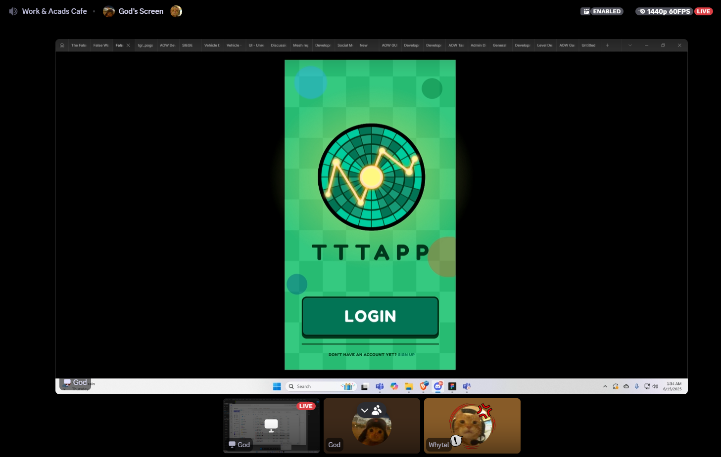

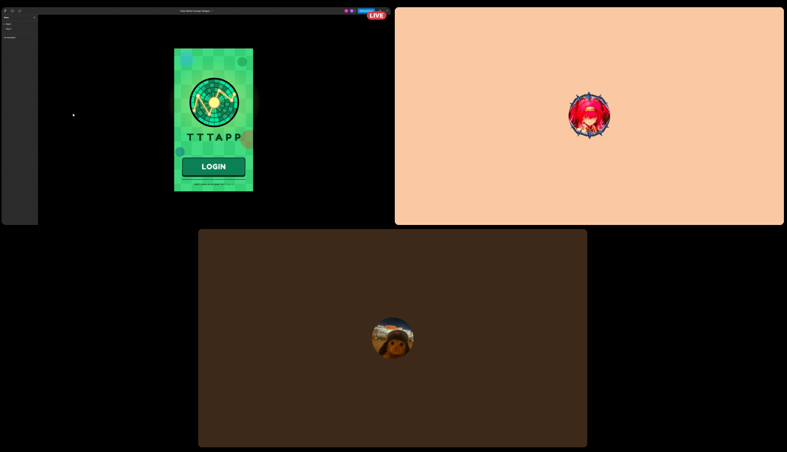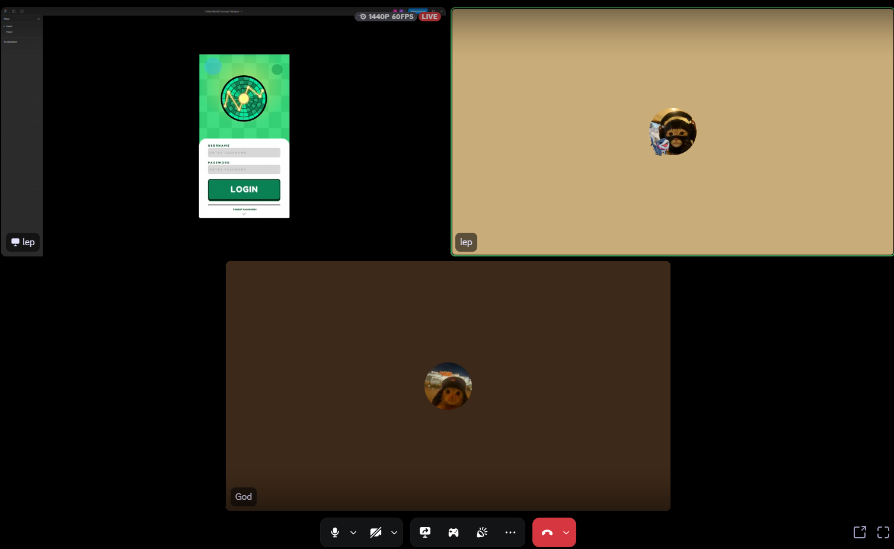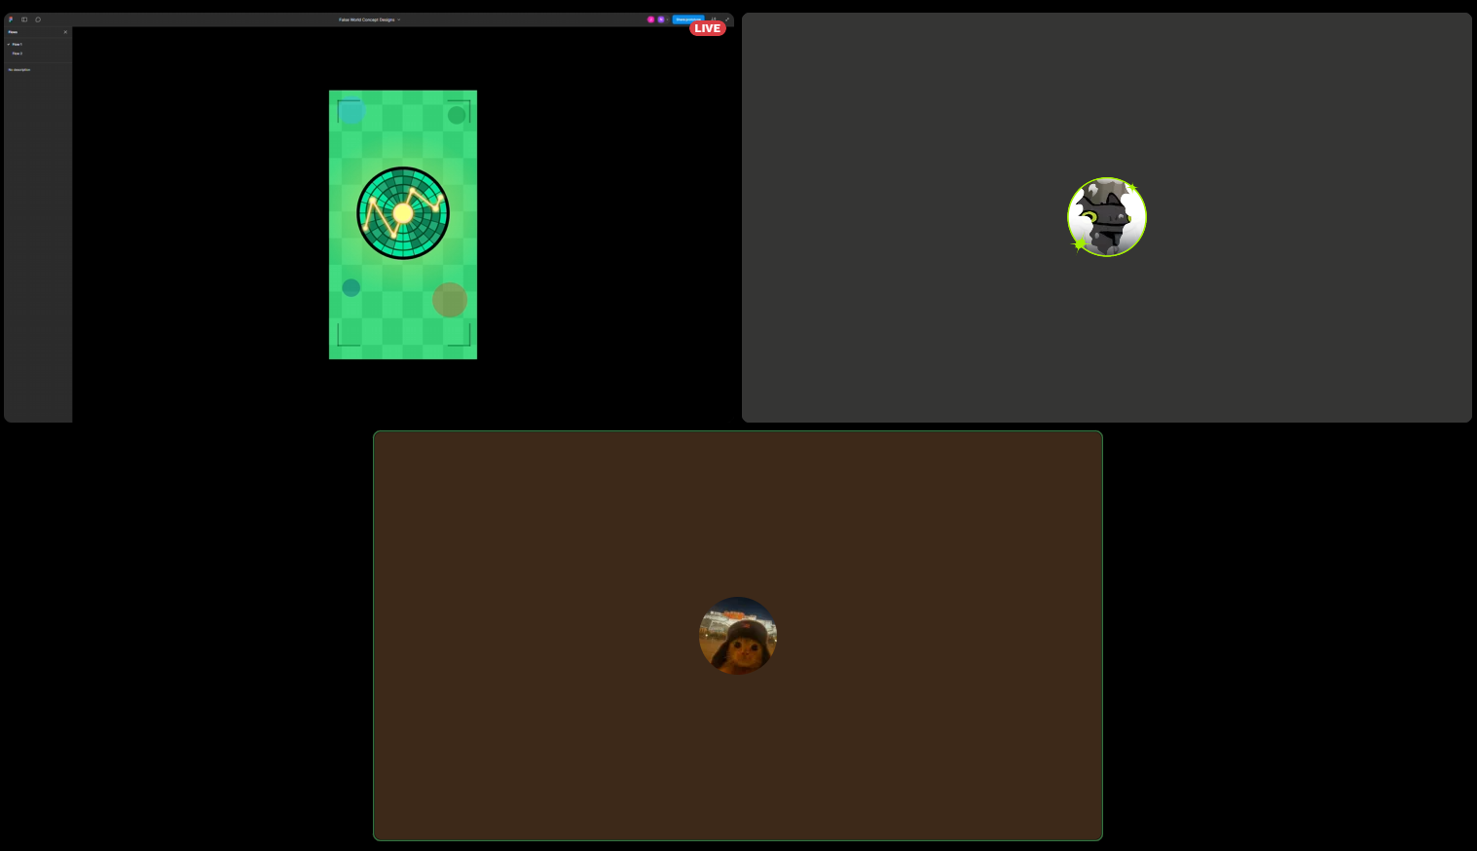

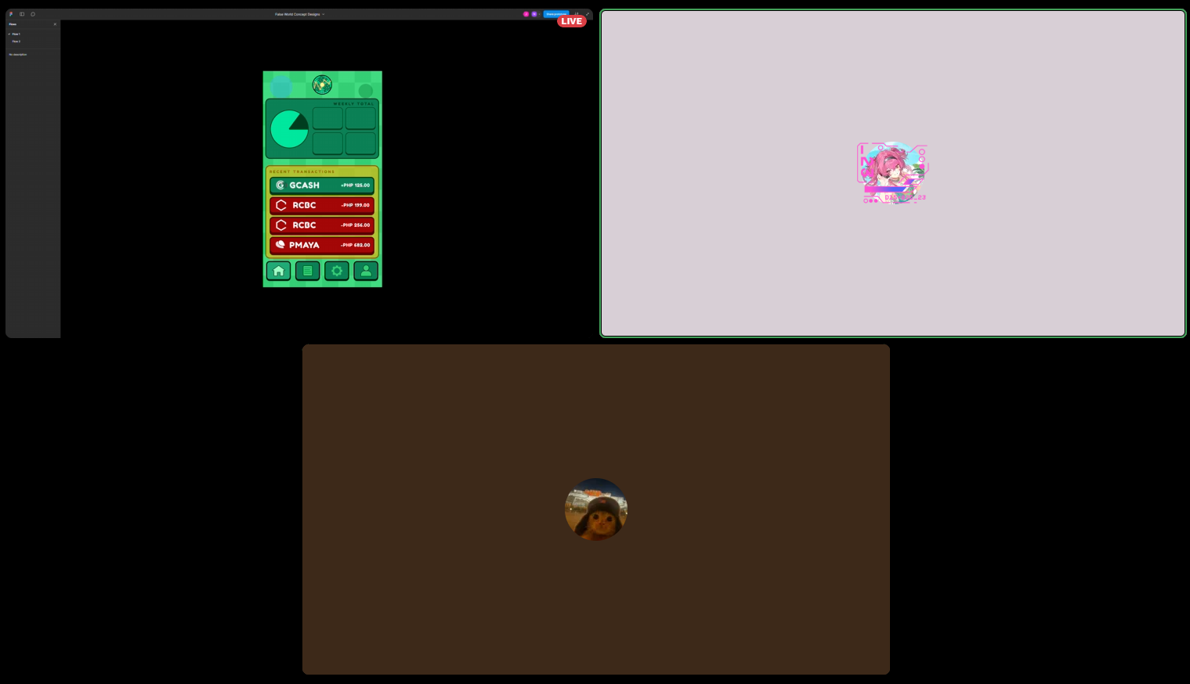

**Data Presentation**

**Data Analysis**

***Usability Specifications***

During the online testing with the Participants, Team TAAL has noticed that the participants during this test have been interacting rather well with the prototype. Almost all the Participants were able to finish each task handed to them by the Members of the Team and were accomplished with little to no issues. Upon further observation, the participants were able to learn and memorize the steps and navigation of the Prototype. They were able to easily navigate their way through the prototype. However, some buttons on the Prototype were inattentive when the participants attempt to click. This is presumed to be constraint issues that were missed by the pair during the designing of the prototype.

|  |  |  |  |
| --- | --- | --- | --- |
| Task | Mean | Interpretation | Classification |
| Main Menu Task | 1 minute | Highly Acceptable | Successful |
| Login Screen | 0.2 minute | Highly Acceptable | Successful |

Table 3. Task Time

Table 3 shows the results of the timed tasks during the Online Testing. The data shows that the Participants were overall able to accomplish each task sections with amazing times. With this result, the prototype is interpreted as successful in all three (3) task sections.

***Heuristic Evaluation***

The TTTAPP prototype will be evaluated within each type of Heuristic Evaluation.

|  |  |  |  |  |  |
| --- | --- | --- | --- | --- | --- |
| **Area of Evaluation** | **5** | **4** | **3** | **2** | **1** |
| 1. **Visibility of System Status**  * - The system design provides appropriate feedback like message prompts in response to user actions. * The message prompts are clear, visible and understandable. | **✓** |  |  |  |  |
| **✓** |  |  |  |  |
| **Evaluation**  You always know what’s happening. If you’re playing a song or downloading something. It shows right away in the interface. | | | | | |
| 1. **Match between the system and the real world**   - Used words, phrases and concepts according to users’ language rather than system oriented words and computer jargons. | **✓** |  |  |  |  |
| 1. **User control and freedom**   - The system design provides ways of allowing users to easily “get in” and “get out” if they find themselves in unfamiliar parts of the system. |  | **✓** |  |  |  |
| 1. **Consistency and Standards**  * - The colors, text, labels, buttons and other elements in the design are uniform from start to finish**.**   - Text and icons are not too small or too big.  **-** Menus and other features of the system are arranged and positioned in a consistent way. (For ex. If your website has navigation buttons on the top under the page title on one page, the users will automatically look there for the same features on other pages. | **✓** |  |  |  |  |
| **✓** |  |  |  |  |
| **✓** |  |  |  |  |
| 1. **Error Prevention**   - The system design provides an automatic detection of errors and preventing them to occur in the first place.  - Idiot proofing mechanisms are applied | **✓** |  |  |  |  |
| **✓** |  |  |  |  |
| **F. Help users recognize, diagnose and recover from errors**  **-** Error messages and the terms used are recognizable, familiar and understandable for the users. |  | **✓** |  |  |  |
| **G. Recognition rather than recall**  **-** Objects, icons, actions and options are visible for the user.  - Objects are labeled well with text and icons that can immediately be spotted by the user and matched with what they want to do. | **✓** |  |  |  |  |
| **H. Flexibility and efficiency of use**  - The system design provides easy to navigate menus.  - the system does not make wasteful time of system resources. |  | **✓** |  |  |  |
| 1. **Aesthetic and minimalist design**   **-**Graphics and animations used are not difficult to look at and does not clutter (mess) up the screen.  - Information provided is relevant and needed for the system design. | **✓** |  |  |  |  |
| 1. **Help and Documentation**   **-**the system design provides information that can be easily searched and provides help in a set of concrete steps that can easily be followed. | **✓** |  |  |  |  |

***Participant Interview and Feedback***

**Results**

|  |  |  |  |
| --- | --- | --- | --- |
| **SECTION 1** | | | |
| Question | Mean | Interpretation | Classification |
| On a scale of 1 to 5 how would you rate your experience with the TTTAPP Prototype | 4 | Acceptable | Successful |
| On a scale of 1 to 5 how was the UI design of the prototype | 5 | Acceptable | Successful |
| How easily were you able to follow the tasks provided | 5 | Acceptable | Successful |
| **SECTION 2** | | | |
| Login Screen | 5 | Acceptable | Successful |
| Accessing Main Menu | 5 | Acceptable | Successful |
| Navigating the different tabs | 4 | Acceptable | Successful |
| Checking detailed summaries in profile | 4 | Highly Acceptable | Successful |

|  |  |  |  |
| --- | --- | --- | --- |
| **Average** | 4.57 | Acceptable | Successful |

Table 3. Interview Data Interpretation

The table represents that data for the interview conducted after the online testing. It shows that the prototype is at an Acceptable stage of quality and is deemed Successful. Using the 10 Usability Heuristics Criteria, this data shows that the prototype was able to please the participants and follow the criteria with key points such as its Minimalistic Approach and Visibility.

Feedback

While most of the feedback were overwhelmingly positive. Some feedbacks are focused on a few issues. Such common issues revolve around the inconsistency of one design for the navigation bar.

**Design Implications:**

● Does your prototype need to be altered in order to address the results of the analysis, or was it completely successful?

○ The results of the Prototype show it was very successful and is at an acceptable stage. However, the team still decided to improve upon shower more of the features.

Below are some of the feedbacks that state their concerns about this feature: ■ *The renaming for editing part should be fixed*

■ *One Navigation is inconsistent with the others*

**Critique and Summary:**

What were the advantages and disadvantages of your evaluation?

One big advantage of doing this evaluation was that our team was able to collect important information and data that helped improve the prototype. It was also easier to reach out to participants online, and the evaluation went well since we could just send them the links through social media. But on the downside, we didn’t get to do much in-person testing or any lab work, which could’ve helped us gather even more useful data. Another problem we faced was the slow internet here in the Philippines. It sometimes made it hard to contact participants right away, and it also affected how well we could observe their interaction with the prototype. When the internet was slow, it became harder for us to properly check how the prototype was working on their screens.

What would you have done differently knowing what you know now (both designwise and evaluation-wise)? Given more resources, what could you have done that would have produced significantly more insightful evaluation results (again, whether this is an improved prototype or a different evaluation path).

If we had more time, our team would’ve done two separate evaluations one for the first version of the prototype and another for the updated version. This could have helped us gather more useful feedback and make the prototype more complete. With more resources, we also believe we could’ve added back-end coding to turn the prototype into a real, working app that could be submitted to app stores around the world. We also had plans to add more features like notifications and online functionality to improve the overall experience.

Summary of the Project

The tasks chosen for the prototype were really important because they helped us see how well users could interact with it. These tasks gave us a better idea of what parts worked well and what needed improvement. Some things that worked great were the CRUD system and how easy it was to navigate the app. However, there were a few issues, like the problem with renaming files and some parts of the navigation that didn’t feel consistent. We also weren’t able to add online features due to time constraints. If we had more time, we would’ve added those, along with music features and other ideas to make the prototype more fun and unique.

What we learned from this project is that designing a prototype isn’t easy. It takes a lot of knowledge about UI design and a good understanding of the problem you're trying to solve and who you're designing for. Through this project, we also saw that the participants were actually pretty familiar with Android interfaces, even though it was their first time using our prototype. Overall, we believe the design turned out well and was good enough to be considered a success.